

|  |  |
| --- | --- |
| **Program Name and Code: CO6I** | **Academic Year : 2023-24** |
| **Course Name and Code: PHP(22616)** | **Semester : Sixth** |

**A STUDY ON**

**VIDEO TO AUDIO CONVERTER**

***MICRO PROJECT***

|  |  |  |  |  |
| --- | --- | --- | --- | --- |
| **Sr. No** | **Roll No (Sem-VI)** | **Full name of Student** | **EnrollmentNo** | **Seat No (Sem-VI)** |
| 01 | 21 | JANHVI VIJAYKUMAR KATAKDHOND | 2117340059 | 281956 |

Under the Guidance of

**Prof. S. S. Doifode**

in

**Three Years Diploma Programme in Engineering & Technology of Maharashtra State Board of Technical Education, Mumbai (Autonomous)**

**ISO 9001:2008 (ISO/IEC-27001:2013)**

at

**1734 – TRINITY POLYTECHNIC PUNE**



**MAHARASHTRA STATE BOARD OF TECHNICAL EDUCATION, MUMBAI**

***Certificate***

This is to certify that Ms. Janhvi Vijaykumar Katakdhond

Roll No: of **Sixth Semester** of **Diploma Programme in Engineering & Technology** at **1734 – Trinity Polytechnic Pune,**has completed the **Micro Project** satisfactorily in Subject ______________in the academic year 2023-24 as per the MSBTE prescribed curriculum of I Scheme.

Place : Pune Enrollment No: 2117340059

Date: / /2024 Exam Seat No:

# Project Guide Head of the Department Principal

**INDEX**

|  |  |  |
| --- | --- | --- |
| **Sr No.** | **Title** | **Page No.** |
| **1.** | **Abstract** | **04** |
| **2.** | **Introduction** | **06** |
| **3.** | **Python Installation Process** | **08** |
| **4.** | **Source Code/Program** | **14** |
| **5.** | **Output** | **17** |
| **6.** | **Conclusion** | **19** |
| **7.** | **References** | **20** |

**Abstract**

Video to Audio Converter is an application that converts a video file to an audio file. Here the user gets a GUI Window where he can choose a video file from and this file is converted using the button on the GUI Window. This video file is converted into audio and saved in the system. Let us start building the video to audio converter project using Python modules.

* **Aims/Benefits of Microproject-**

To write a simple program to develop Video to audio converter.

* **Course Outcomes-**

1. Develop Program to develop Video to audio converter using Python.
2. Develop programs using python basics and various packages.
3. Learn how to implement packages simply and successfully in program.

* **Proposed Methodology-**

First of all we searched the topic for our microprojectad finalize it.We write a simple program in Python develop the video to audio converter. we write the program with the help of reference books and some other internet facilities. And find out the errors and successfully run the program.

* **Resources Required-**

|  |  |  |  |
| --- | --- | --- | --- |
| Sr. No. | Resources | Specification | Quantity |
| 1 | Computer system | Lenovo,8GB,  Windows11 | 1 |
| 2 | Software | Python3.1.12 | 1 |
| 3 | Internet Facilities | Chrome | 1 |

* **Rationale**-

Advanced java is an technology or advance version of java specially designedto delovlop web based and enterprise application.By using these features of advanced java like AWT, Swing and event. we created the tic toc toe game.

* **Aims/Benefits of Microproject-**

To write a simple program to develop Video to Audio converter using Python.

* **Course Outcomes Achieved-**

1. Develop Program to develop Video to audio converter using Python.
2. Develop programs using python basics and various packages.
3. Learn how to implement packages simply and successfully in program.
4. **Actual Proposed Methodology-**

First of all we searched the topic for our microprojectad finalize it.We write a simple program in Python develop the video to audio converter. we write the program with the help of reference books and some other internet facilities. And find out the errors and successfully run the program.

1. **Actual Resources Required-**

|  |  |  |  |
| --- | --- | --- | --- |
| Sr. No. | Resources | Specification | Quantity |
| 1 | Computer system | Lenovo,8GB,  Windows11 | 1 |
| 2 | Software | Python 3.1.12 | 1 |
| 3 | Internet Facilities | Chrome | 1 |

1. **Skills Developed-**
2. Devloped better communication skills.
3. Leadership and team work skills are developed.
4. Soft skills like self confidence and the other hand basic start up knowledge, business planning, and financial literacy.
5. Know and understood How to implement the knowledge practically.

* **Application of Microproject-**

1. Make video to audio converting easy.
2. Easy work in editing

**Introduction**

**About Video To Audio Converter**

The objective of a video to audio converter is to convert a video file and save it in the system after changing it to an audio file. In this game, we are going to browse a video file and convert it to an audio file.

**Python Video to Audio Converter Project Details**

In this project, the user will have to take the following steps:

1. Click on Browse Button
2. Browse a video file
3. Click on Save Button
4. The video file is successfully saved.

This project can be created using the MovieEditor Module

### **Steps to Build Python Video to Audio Converter Project**

Let us look at the steps to create the Video to Audio Converter Project:

1. Importing the modules
2. Creating the GUI Window
3. Browse Function
4. Save Function

#### **1. Importing the Modules:**

import moviepy.editor

from tkinter.filedialog import *

from tkinter import *

* Here we are importing the required modules.

#### **2. Creating the GUI Window:**

window=Tk()

# Set the size of the tkinter window

window.geometry("700x350")

window.title("PythonGeeks")#give title to the window

Label(window, text="VIDEO TO AUDIO CONVERTER",bg='orange', font=('Calibri 15')).pack()# a label

Label(window, text="Choose a File ").pack()

* Tk() – is a method that helps us create a blank GUI window.
* geometry() – is a method that helps us fix the size of the GUI Window.
* title() – is a method that helps us fix the title of the GUI Window.
* Label() – is a method that helps us create a widget to display text on the GUI WIndow.

pathlab = Label(window)

pathlab.pack()

#creating buttons

Button(window,text='browse',command=browse).pack()

Button(window,text='SAVE',command=save).pack()

* Button() – is a method that helps us create a button on the GUI Window.

#### **3. Browse() function:**

def browse():#browsing function

global video#global variable

video = askopenfilename()

video = moviepy.editor.VideoFileClip(video)

pathlab.config(text=video)#configure method

* Creating a global variable
* askopenfilename() – this function helps the user browse files from the GUI Window.
* config() – this method configures the pathlab label.

#### **4. Save() Function:**

def save():

audio = video.audio#convert to audio

audio.write_audiofile("sample.wav")#save as audio

Label(window, text="Video Converted into Audio and Saved Successfully",bg='blue', font=('Calibri 15')).pack()# a label

* Video.audio – converts the video file to audio file.
* write_audiofile() – this method save the audio file in the system.

**Python Installation Process**

Guide to installing Python on Windows 10:

**1. Download Python Installer**: Visit the official Python website at python.org and head to the Downloads section. There, you'll find the latest version of Python for Windows. Make sure to select the version that matches your system architecture (32-bit or 64-bit). Click on the download link to obtain the installer file. It's usually named something like "python-3.x.x.exe", where "x.x" denotes the version number.

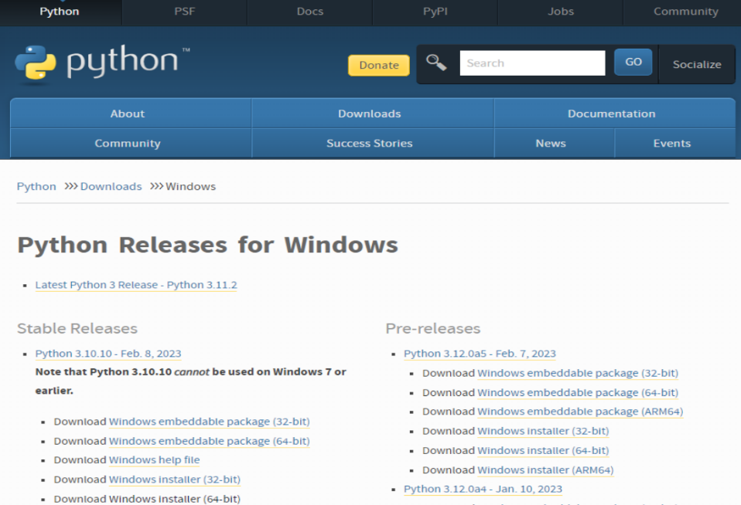

**2. Run the Installer**: Once the download completes, locate the downloaded installer file and double-click on it to launch the Python installation wizard.

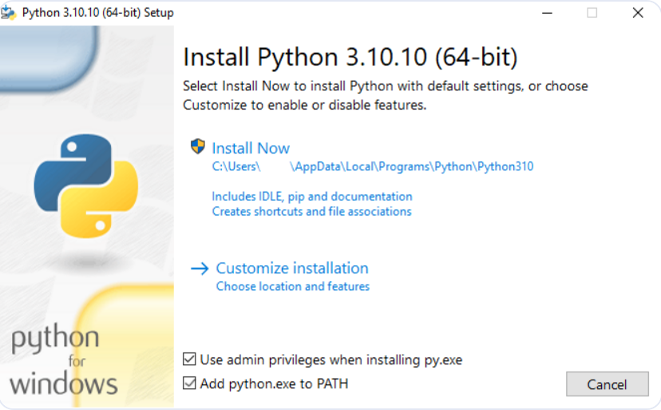

**3. Configure Installation Options**: The installation wizard will open with several configuration options. The most crucial checkbox is labeled "Add Python x.x to PATH". Ensure this option is selected. Adding Python to the PATH environment variable allows you to run Python from any command prompt window without specifying the full path to the Python executable. Click on the "Install Now" button to proceed with the default installation settings.

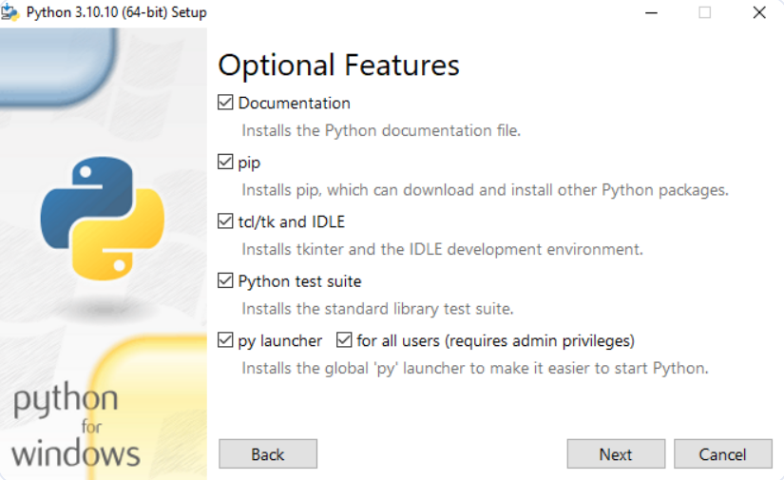

4. **Customize Installation (Optional**): If you have specific requirements, you can click on the "Customize installation" button to modify the installation settings. Here, you can choose the features you want to install, change the installation directory, or even install Python for all users. For most users, the default settings work fine.

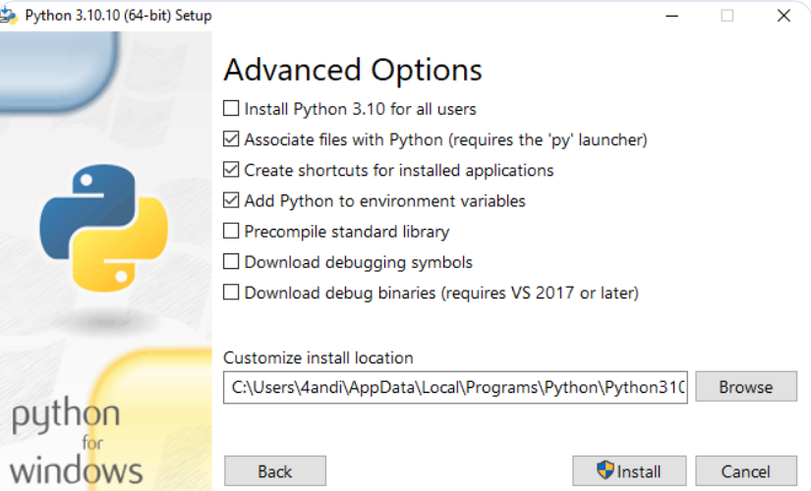

5.**Begin Installation**: After configuring the installation options, click the "Install Now" button to start the installation process. The installer will copy the Python files to the designated directory and configure Python on your system. This process may take a few minutes to complete, depending on your system's speed.

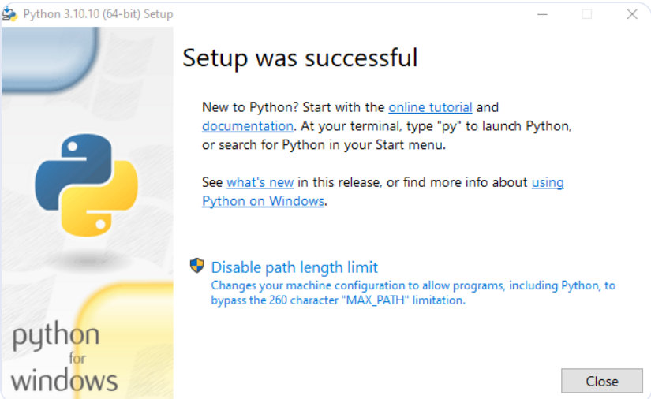

6. **Verify Installation**: Once the installation finishes, you can verify that Python is correctly installed by opening a Command Prompt window. Type `python --version` and press Enter. This command displays the installed Python version. You can also type `python` and hit Enter to enter the Python interpreter, where you can execute Python code directly.

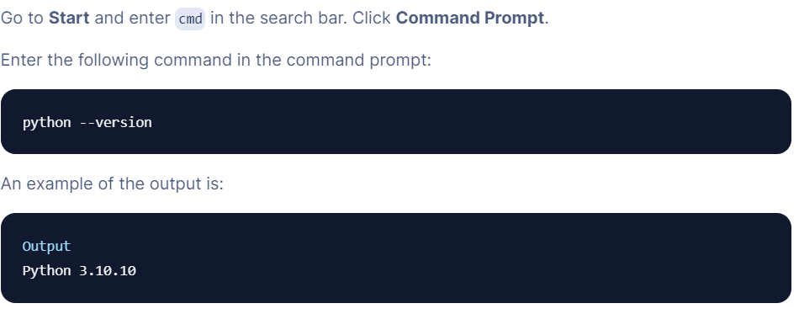

7. **(Optional) Install a Code Editor or IDE**: While Python comes with IDLE (Python's Integrated Development and Learning Environment), you might prefer using a different code editor or integrated development environment (IDE) for writing and running Python code. Popular choices include Visual Studio Code, PyCharm, and Sublime Text. Download and install the preferred editor/IDE from their respective websites.

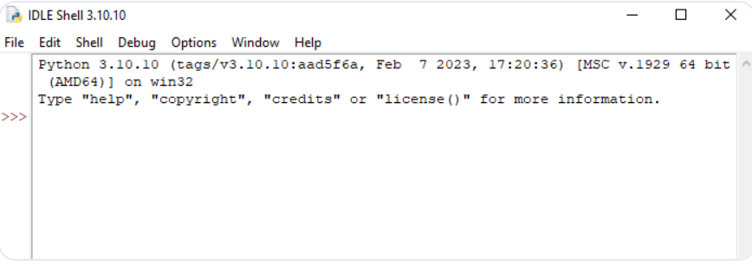

**Source Code/Program**

#importing modules

import moviepy.editor

from tkinter.filedialog import *

from tkinter import *

window=Tk()

# Set the size of the tkinter windowdow

window.geometry("700x350")

window.title("Janhvi Katakdhond(TYCO)")#give title to the window

Label(window, text="VIDEO TO AUDIO CONVERTER",bg='orange', font=('Calibri 15')).pack()# a lable

Label(window, text="Choose a File ").pack()

def browse():#browsing function

    global video#global variable

    video = askopenfilename()

    video = moviepy.editor.VideoFileClip(video)

    pathlab.config(text=video)#configure method

def save():

    audio = video.audio#convert to audio

    audio.write_audiofile("sample.wav")#save as audio

    Label(window, text="Video Converted into Audio and Saved Successfully",bg='blue', font=('Calibri 15')).pack()# a lable

pathlab = Label(window)

pathlab.pack()

#creating buttons

Button(window,text='browse',command=browse).pack()

Button(window,text='SAVE',command=save).pack()

window.mainloop()

detailed explanation of each part of the code:

**Module Importing**: The code begins with importing necessary modules. moviepy.editor is imported to work with videos, while askopenfilename is imported from tkinter.filedialog to open file dialogs, and Tk and Label are imported from tkinter for GUI components.

**Creating a Tkinter Window**: The code initializes a Tkinter window object using Tk(). The window's size is set to 700x350 pixels, and a title "Janhvi Katakdhond(TYCO)" is assigned to it.

**Adding Labels**: Two labels are added to the window using the Label widget. One label displays "VIDEO TO AUDIO CONVERTER" with an orange background and Calibri font size 15, and the other label displays "Choose a File".

**Browse Function**: The browse() function is defined, which is triggered when the "browse" button is clicked. Inside this function:

The global keyword is used to declare the video variable as a global variable.

The askopenfilename() function opens a file dialog for the user to select a video file. The selected file path is stored in the video variable.

The moviepy.editor.VideoFileClip() function loads the selected video file into the video variable.

**Save Function**: The save() function is defined, which is executed when the "SAVE" button is clicked. Inside this function:

The video.audio attribute extracts the audio from the loaded video file.

The write_audiofile() method saves the extracted audio as a WAV file named "sample.wav".

A label is dynamically created and added to the window, displaying a success message with a blue background.

**Path Label**: A Label widget named pathlab is created to display the path of the selected video file. Initially, it remains empty and will be updated when a file is selected.

**Buttons**: Two buttons are added to the window using the Button widget. One button is labeled "browse" and is associated with the browse() function, while the other button is labeled "SAVE" and is associated with the save() function.

**Mainloop**: The window.mainloop() method starts the Tkinter event loop, which waits for events such as button clicks or window resizing.

**Output**

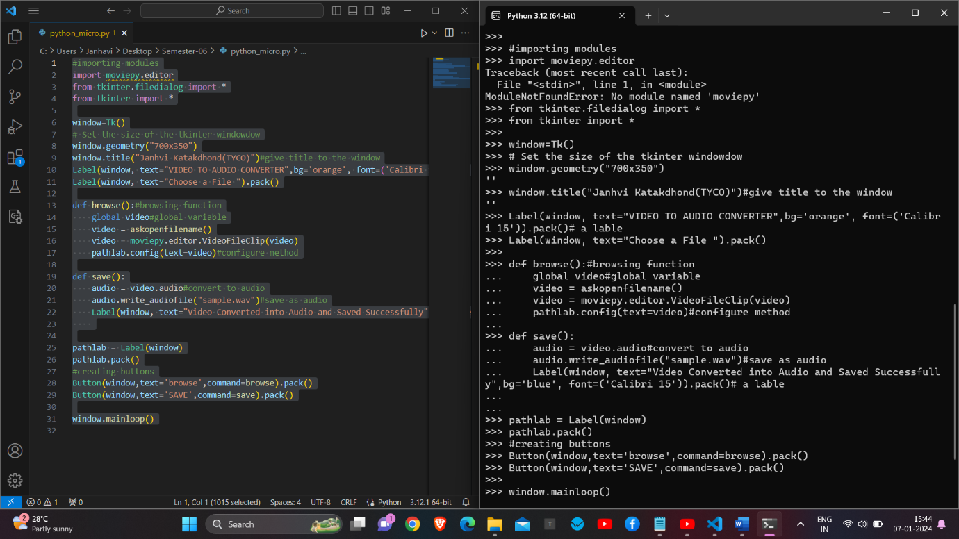

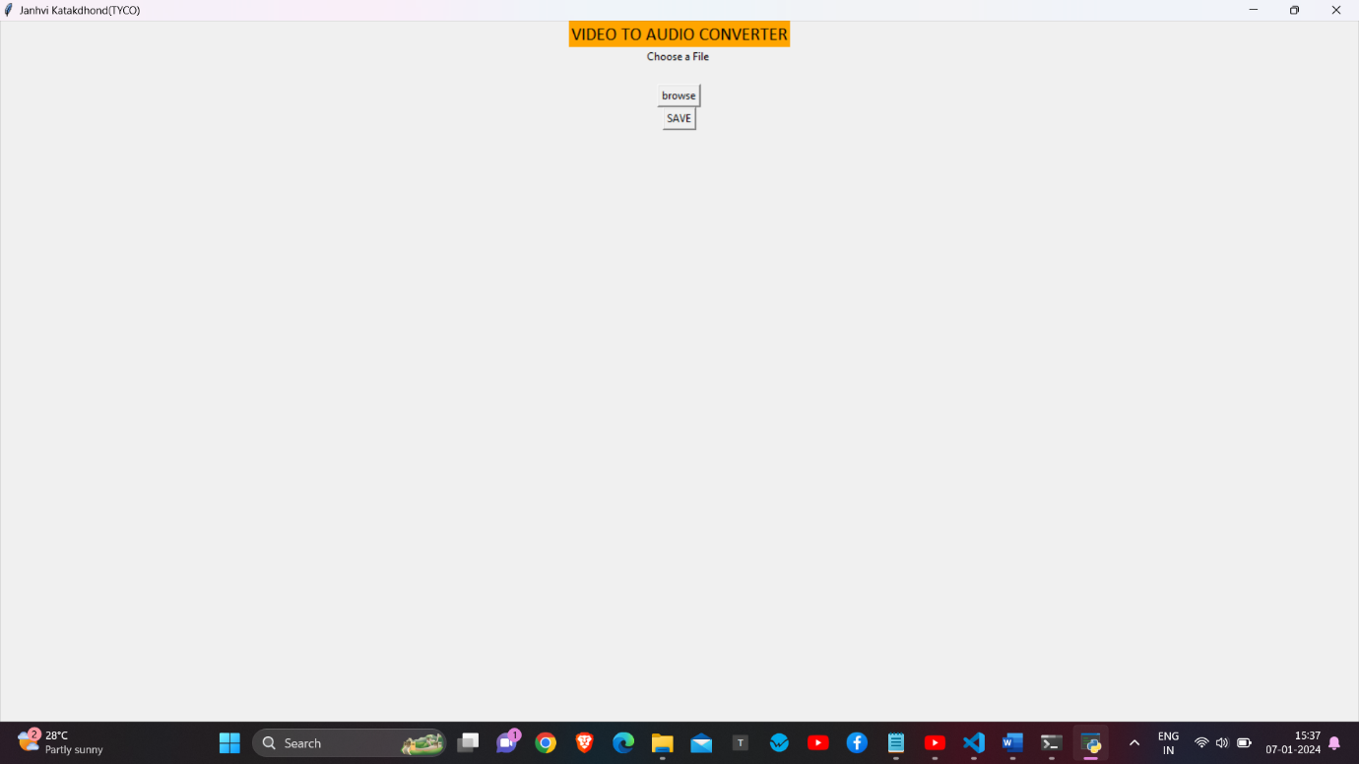

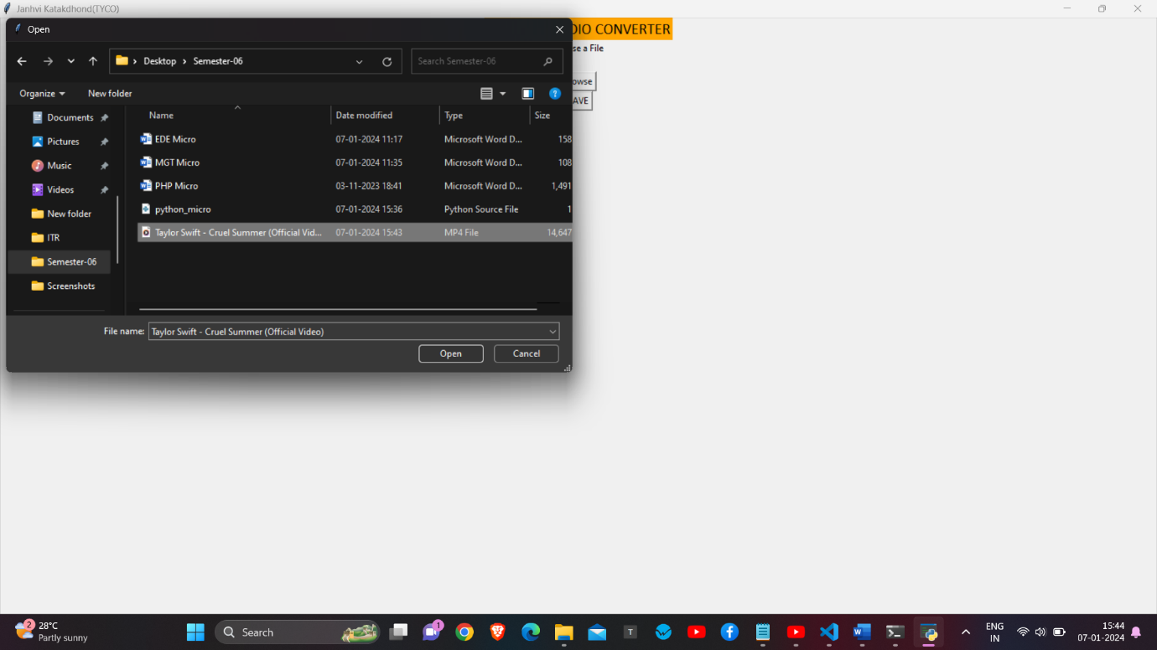

**Conclusion**

Our microproject will be able to implement in future after making some changes and modifications with developing technologies. So the modifications that can be done in our project are:

In future one change can be done by adding the fingerprints of the person of which the address is entered. And one more major change which can be done in this project is that to add snaps of the person of which the address is entered. We can also add or substract details of the individual and more. We can use Css, Andriod,Database based languages, Javascript,etc for make the application of Video to Audio Converter.

**References**

* https://in.search.yahoo.com/search?fr=mcafee&type=E211IN714G0&p=python+project